**DBT ASSIGNMENT-3**

**ASHWIN KRISHNA P**

**PES1201801465**

**SEM:5 , SECTION:F**

**Map Reduce Program**

I am doing standard example of a map-reduce program, that is a Word Count program.

Here I used two python codes, mapper.py and reducer.py

mapper.py

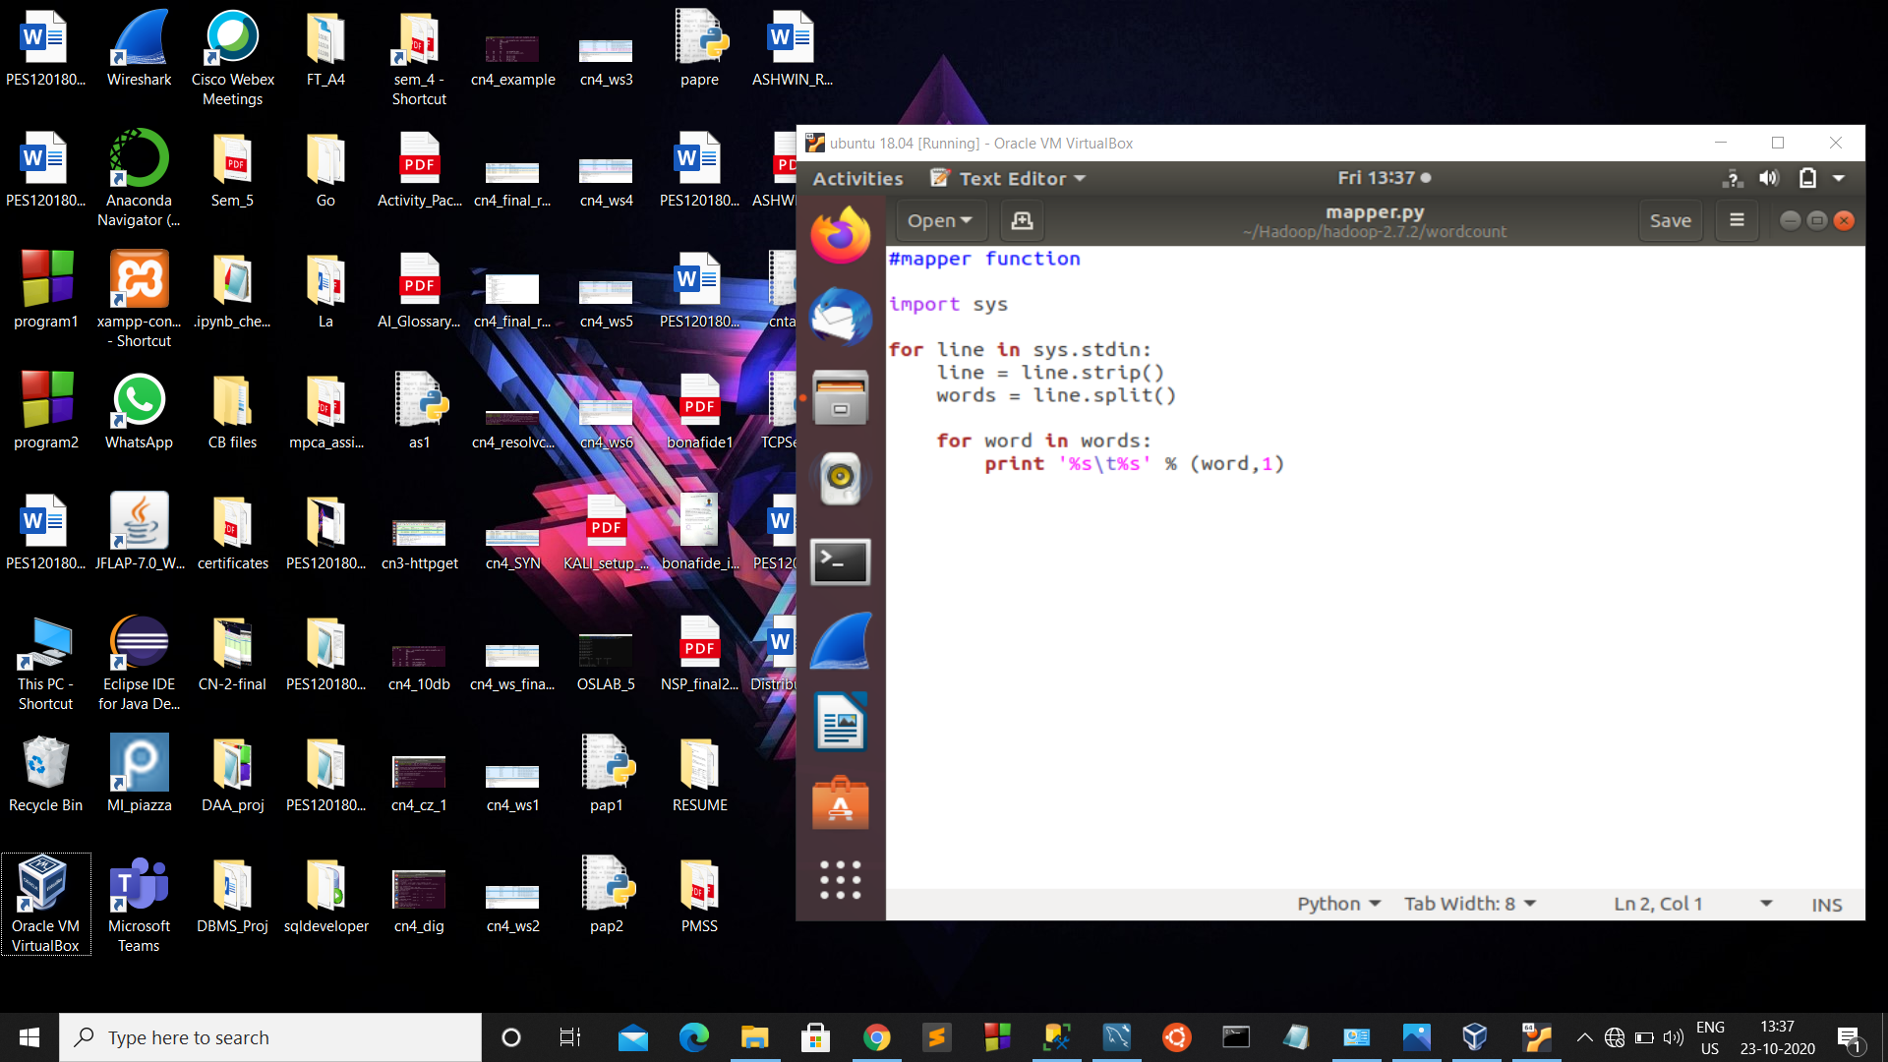

reducer.py

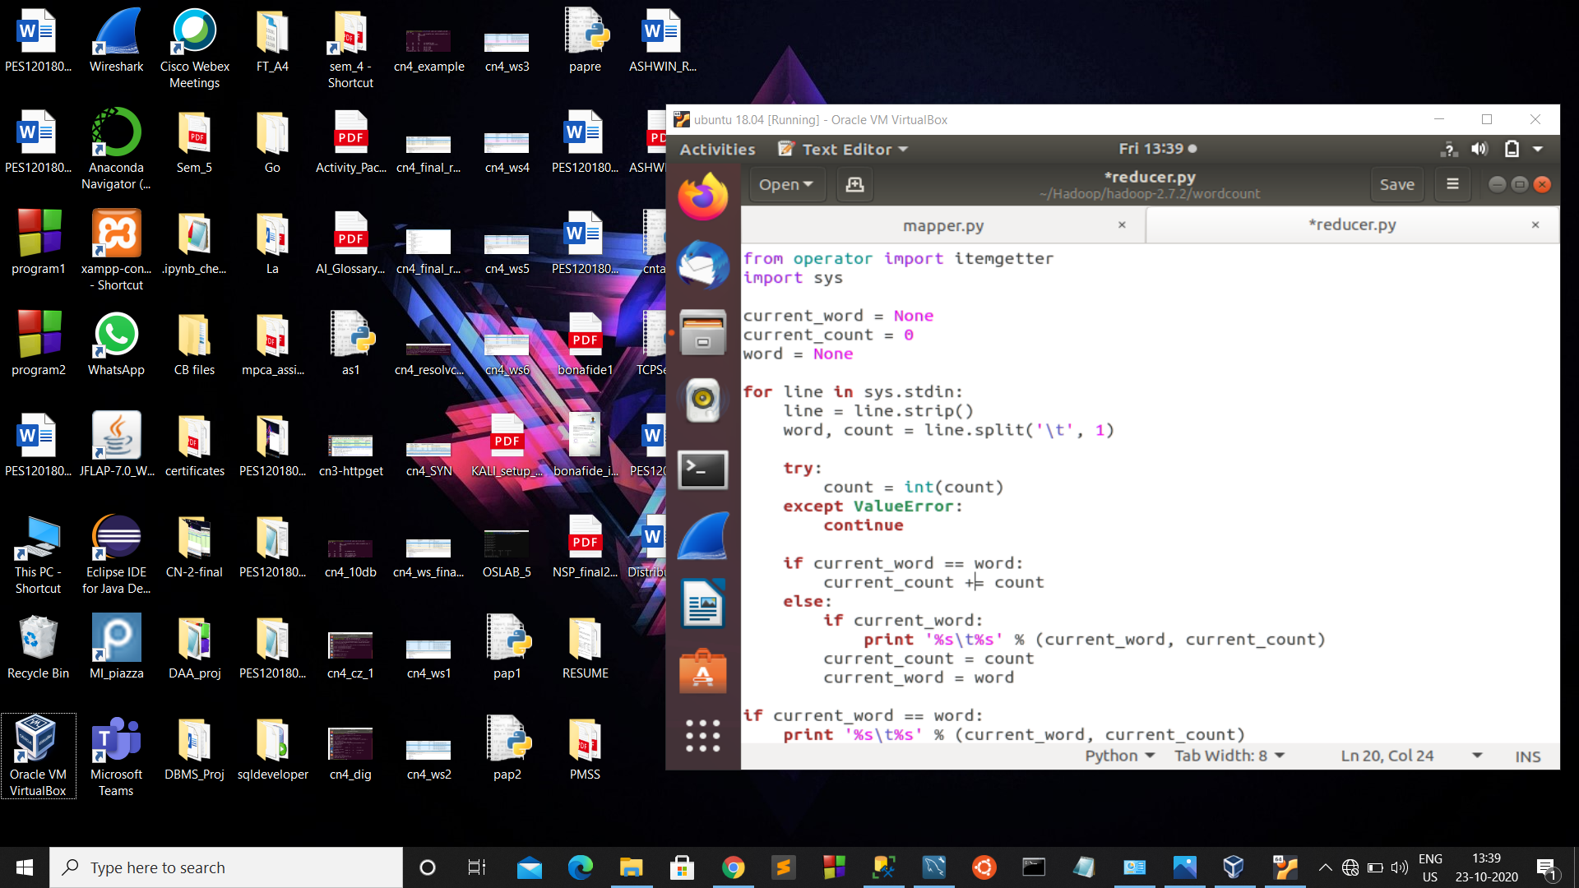

We need a input file, I have taken a simple text file ‘wc_input.txt’ containing some words.

Executing the mapper.py returns each occurrence of a word with its value being 1.

Then the reducer.py calculates the actual count or number of occurrences of a word and gives final result.

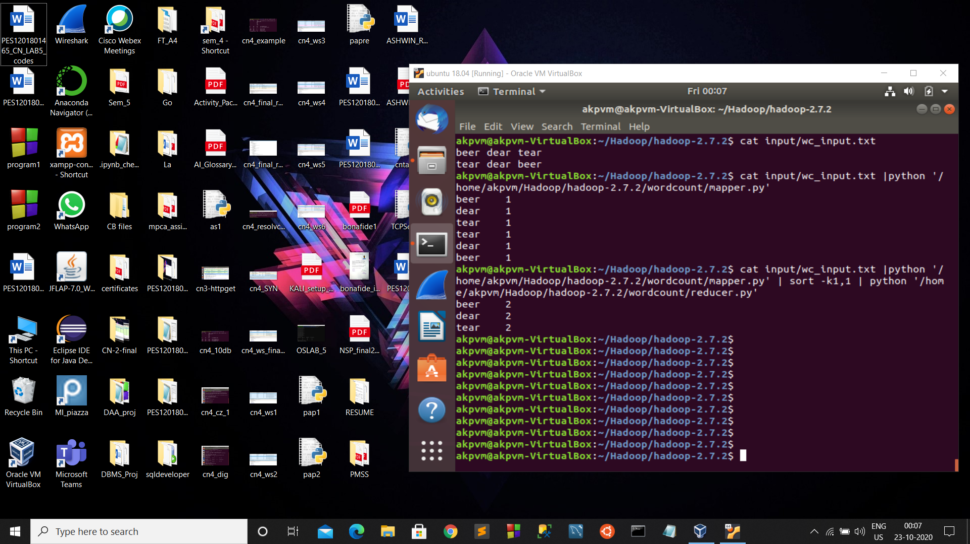

This is the final result.

We can also use Hadoop to run this map-reduce program.

Initially we have to do configurations and create input output directories.

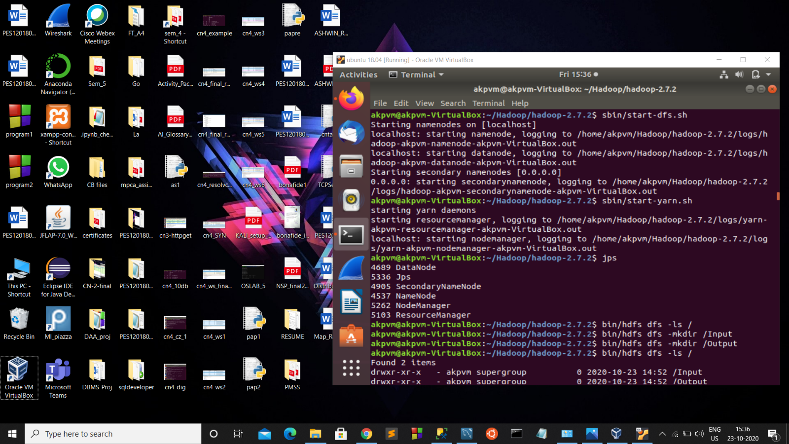

Then we load the input file.

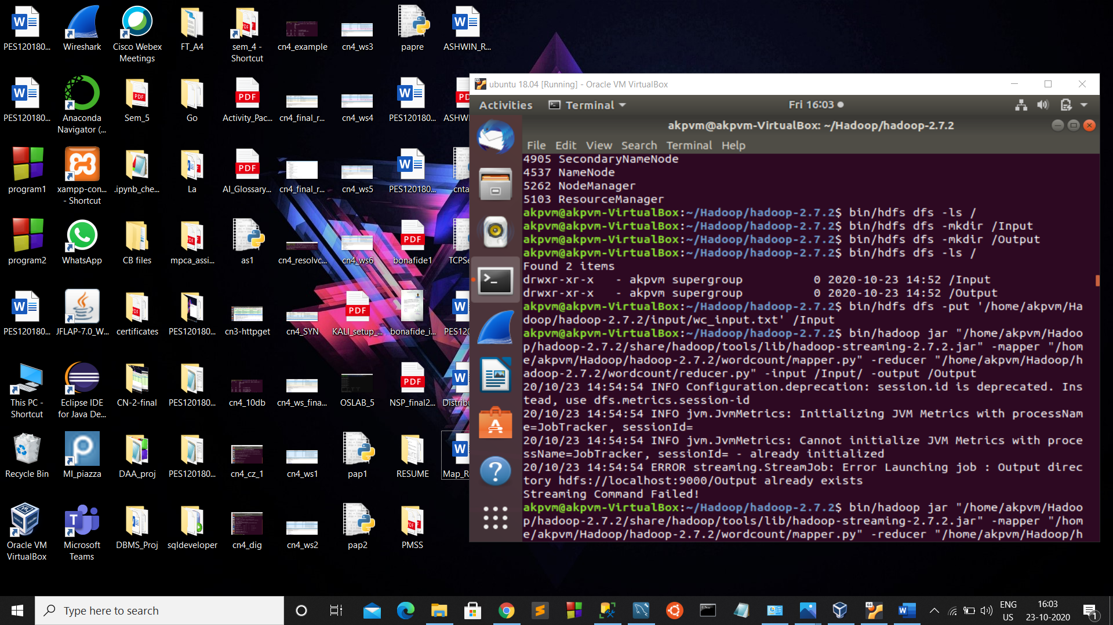

We can see the details and overview the Hadoop environment by visiting ‘https://localhost:50070/’

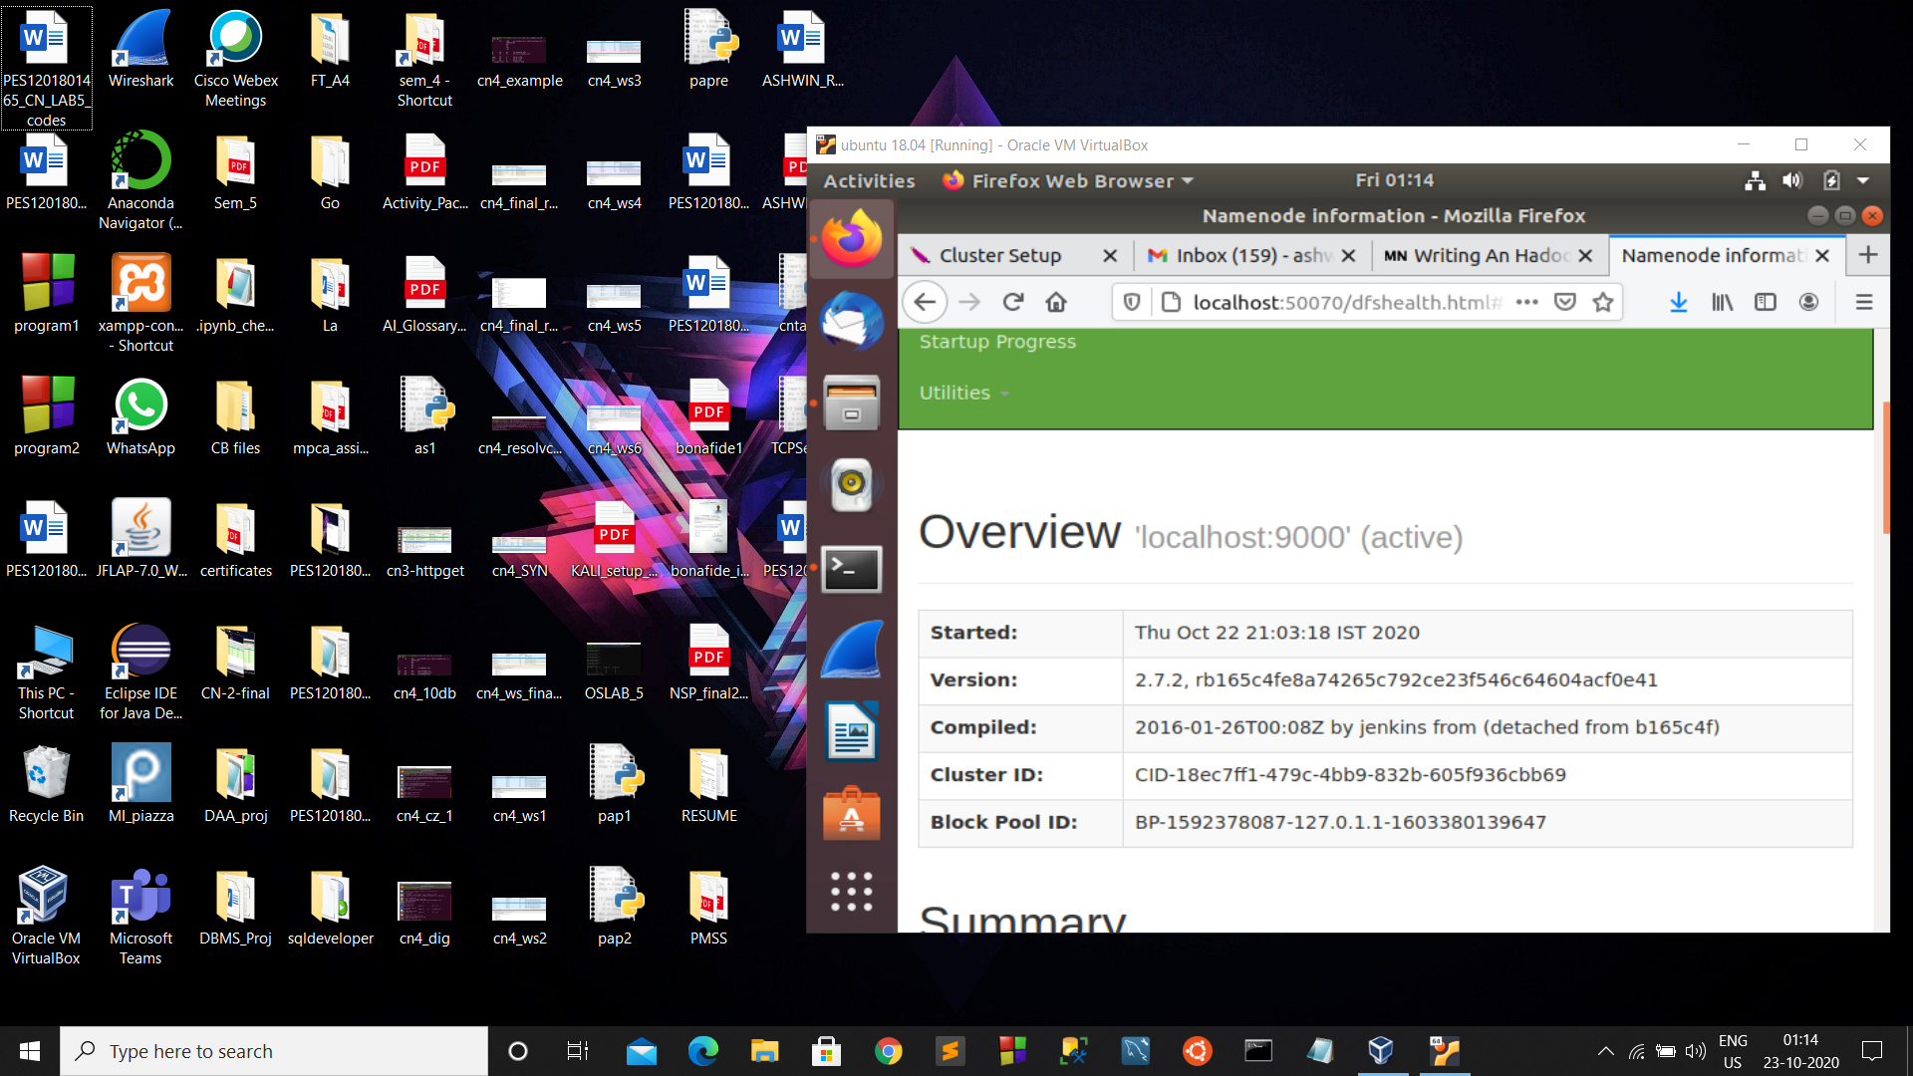

We can also see the input and output directories and file.

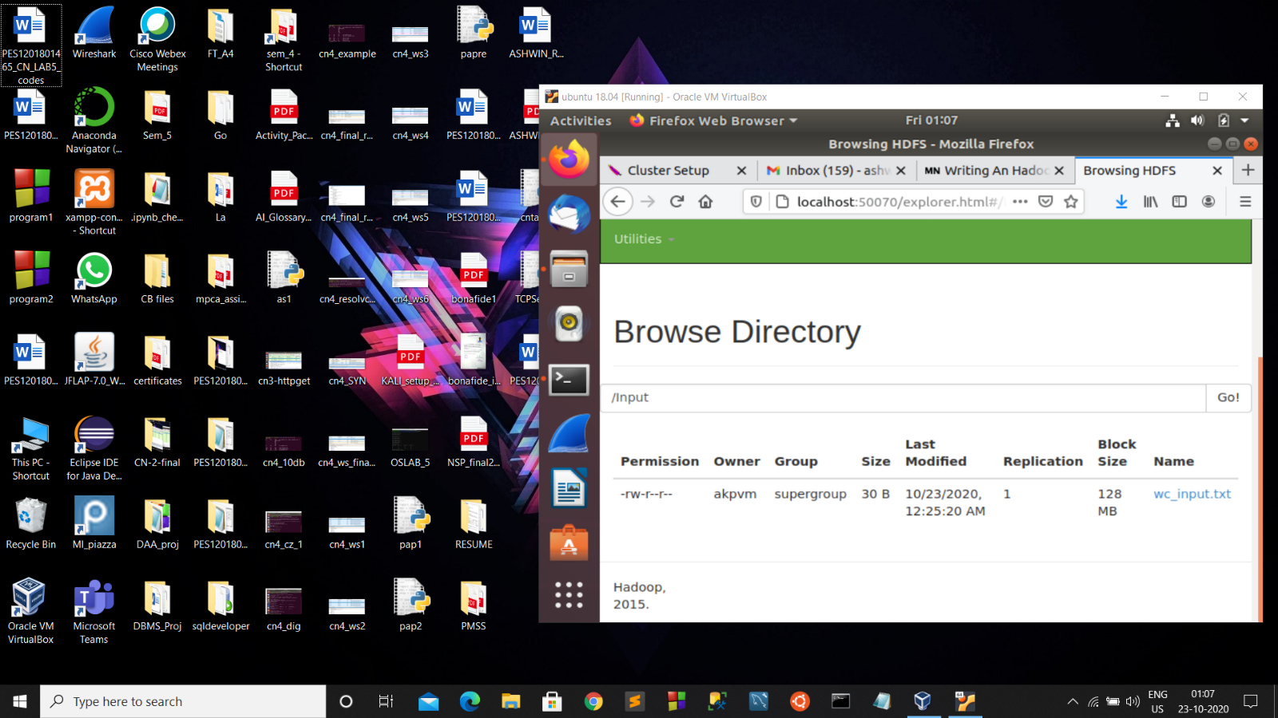

Running the program:

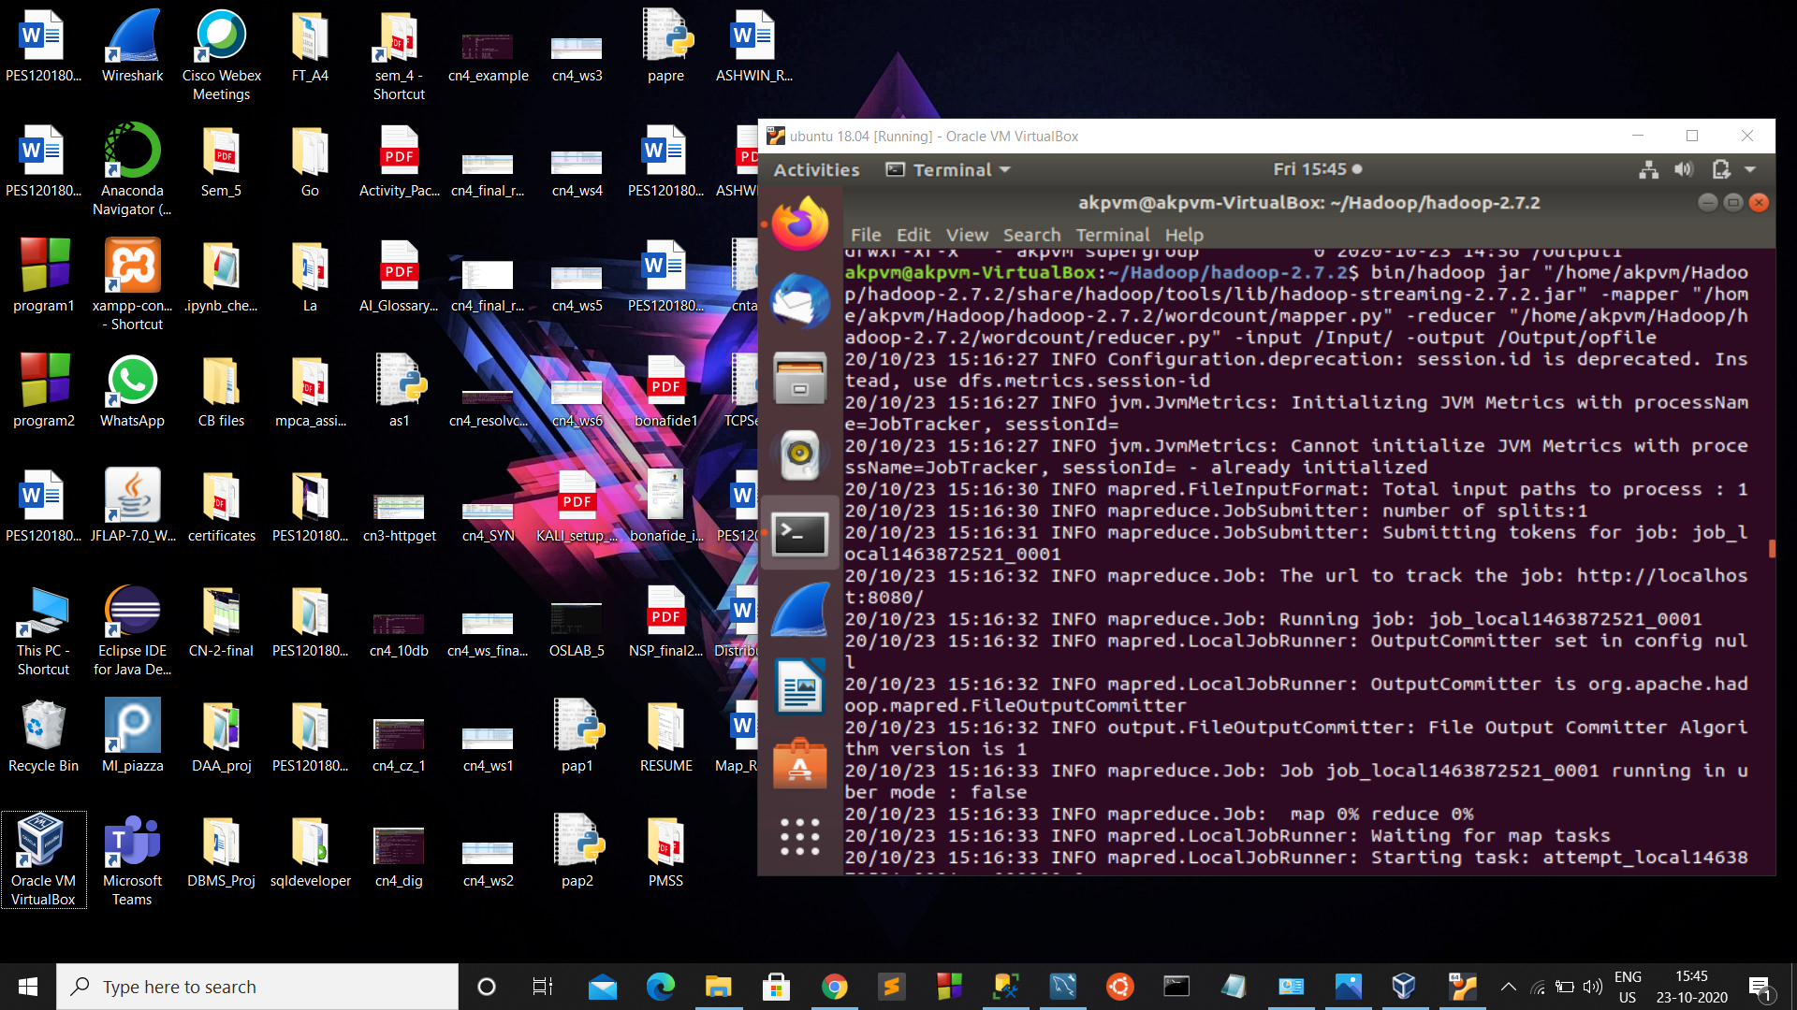

opfile in the Output directory will have 2 files, one is to indicate the success and other, part-00000 will have the result.

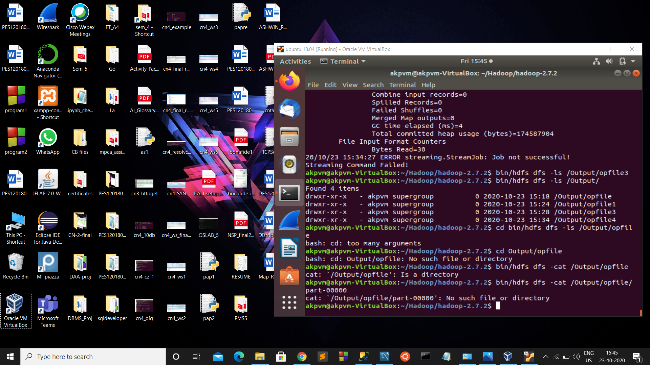

Then we get Final results.



Understandings:-

* A MapReduce program is composed of a [*map*](https://en.wikipedia.org/wiki/Map_(parallel_pattern)) [procedure](https://en.wikipedia.org/wiki/Procedure_(computing)), which performs filtering and sorting , and a [*reduce*](https://en.wikipedia.org/wiki/Reduce_(parallel_pattern)) method, which performs a summary operation. The "MapReduce System" performs the processing by [marshalling](https://en.wikipedia.org/wiki/Marshalling_(computer_science)) the distributed servers, running the various tasks in parallel, managing all communications and data transfers between the various parts of the system, and providing for [redundancy](https://en.wikipedia.org/wiki/Redundancy_(engineering)) and [fault tolerance](https://en.wikipedia.org/wiki/Fault-tolerant_computer_system).
* Large variety of problems can be solved using Map-reduce model
* It is very useful in solving some large computational problems.

Challenges faced:-

I was getting some streaming errors, then I had to rectify it.

**THANK YOU**